1. Write the nationality for the citizens of the following cities.

写出下列城市居民的国籍。

City | Nationality | City | Nationality
Vancouver | (ex.) Canadian | Istanbul | (ex.) Turkish
Tokyo |  | Paris
New York |  | London
Edmonton |  | Melbourne
Buenos Aires |  | Brussels
São Paulo |  | Moscow
Beijing |  | Bangkok
Lima |  | Zurich
Berlin |  | Rome
Seoul |  | Athens
Stockholm |  | Baghdad

2. Identify the following countries and the language they speak there.

找出下列国旗所代表的国家，以及在这些国家使用的语言。

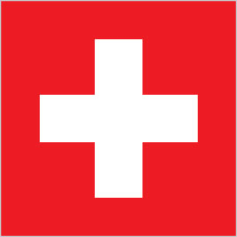 | 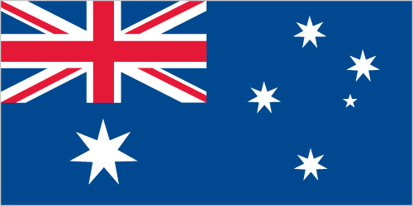
Country:  Language: | Country:  Language:
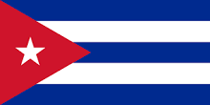 | 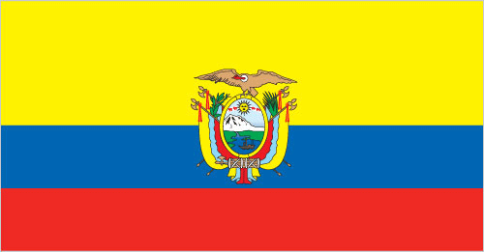
Country:  Language: | Country:  Language:
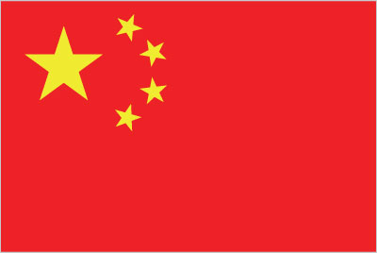 | 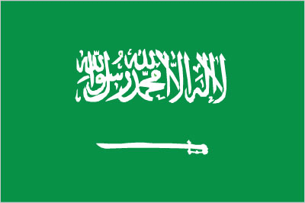
Country:  Language: | Country:  Language:
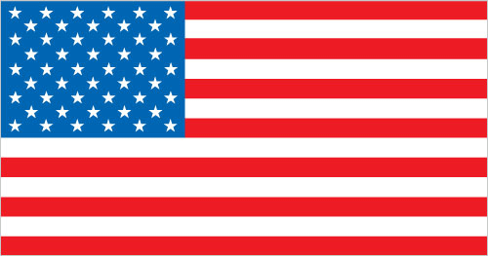 | 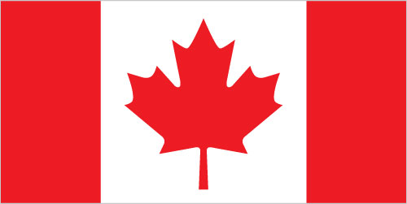
Country:  Language: | Country:  Language:
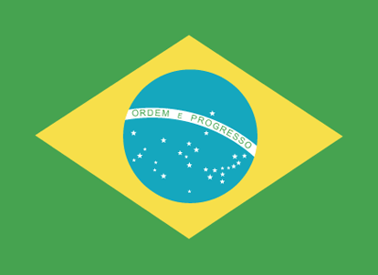 | 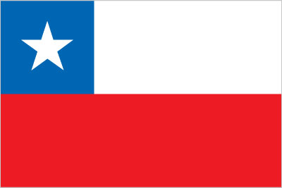
Country:  Language: | Country:  Language:

3. Where are they from?

他们来自哪里？

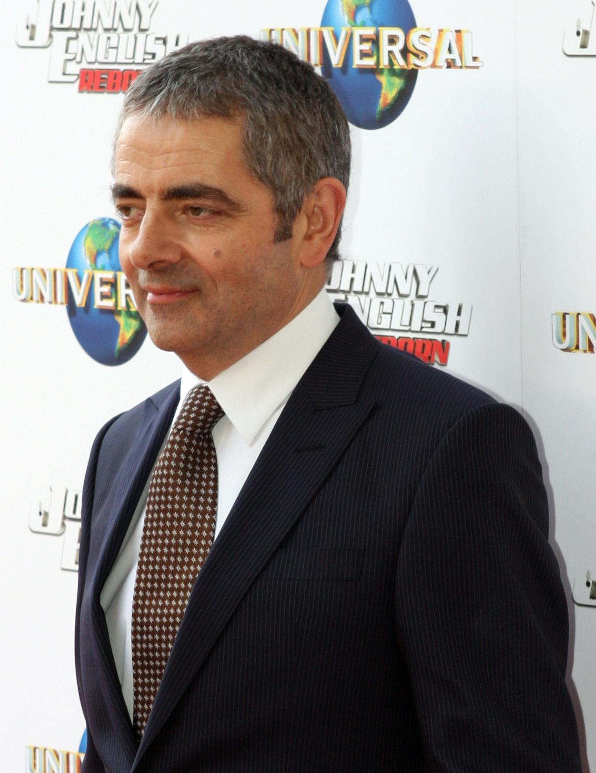 | 
Rowan Atkinson: England | Cameron Diaz: | Orlando Bloom:
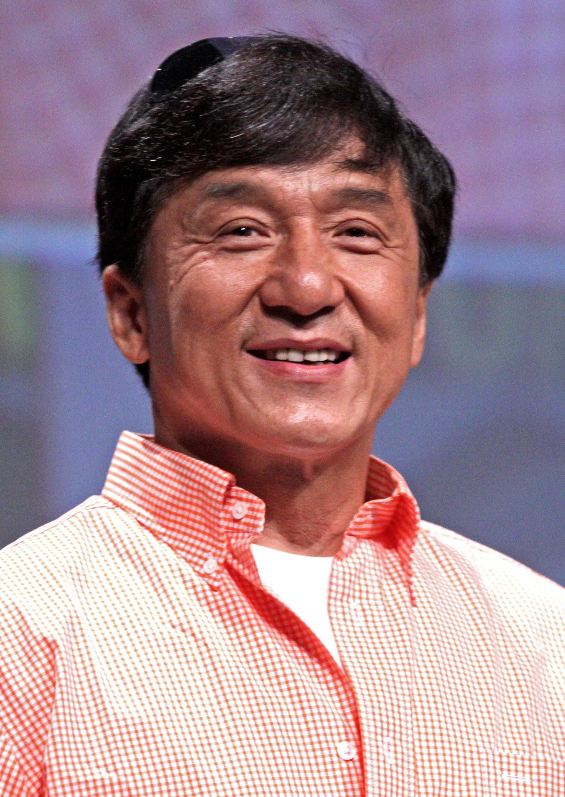 |  | 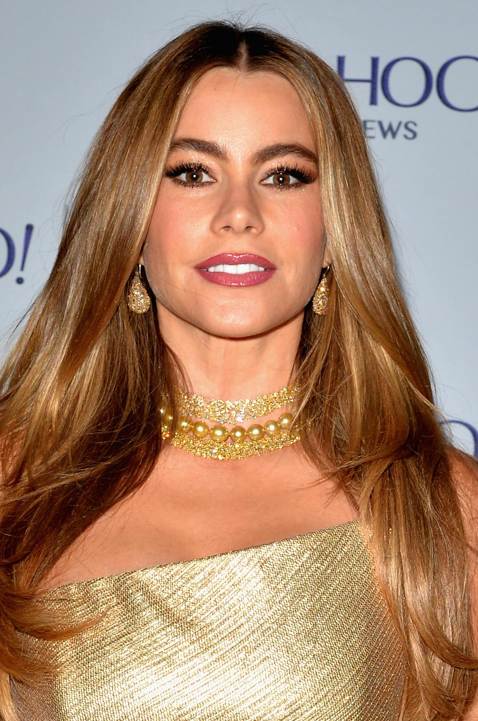
Jackie Chan: | Gael Garcia Bernal: | Sofia Vergara:

4. Name a famous person from ____.

说出来自下列国家的一个名人。

Chile
Brazil
Canada
Australia
France
Venezuela

5. Write sentences about four of the people in questions 3 & 4.

从练习3和4中任选四个人，写出关于他们的句子。

Example
Rowan Atkinson is from England. He is English.

1
2
3
4

Extra Web Exercises
Where is that?
Identify countries of the world
Maps of the world
World Map (Difficult)

