1. What is your favourite plant?

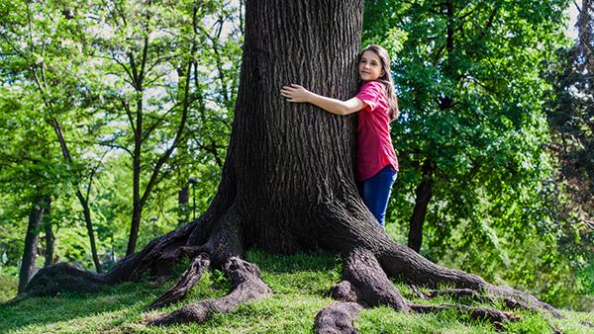

Write your answer.

Practice reading your answer.
Record your voice and listen!

