1. Would you want to go swimming in the ocean? Why or why not?
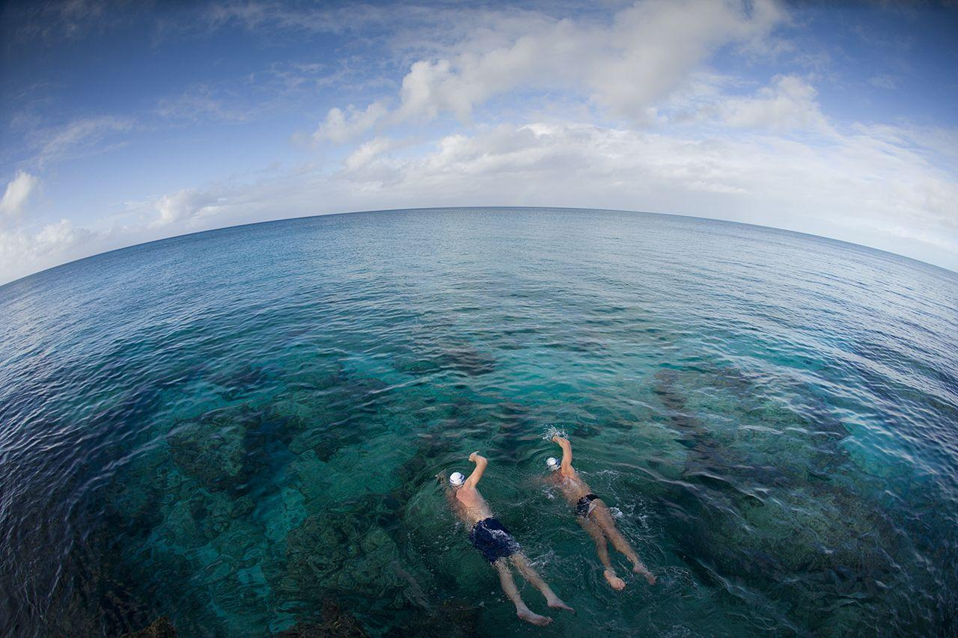

Write your answer.

Practice reading your answer.
Record your voice and listen!

