1. Imagine that you are a fish! What is it like to live in a lake?
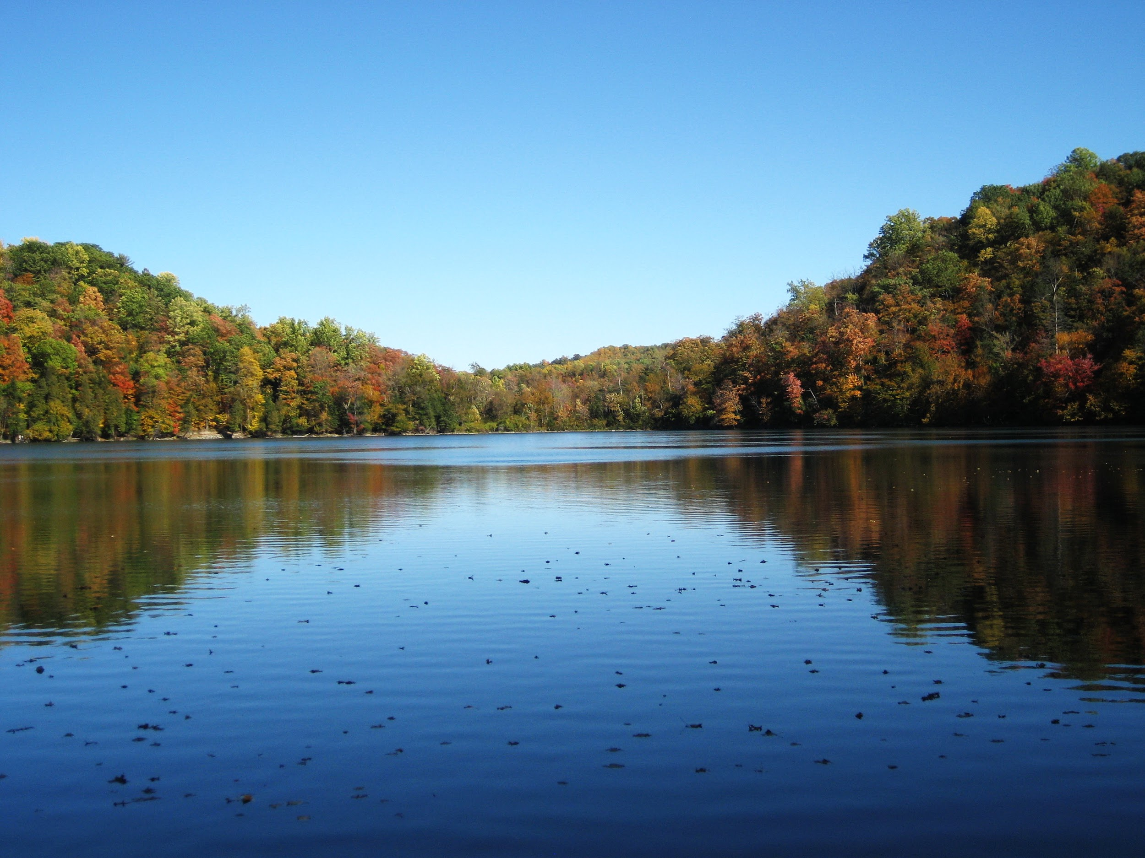

Write your answer.

Practice reading your answer.
Record your voice and listen!

