1. Do you like crocodiles? Why or why not?
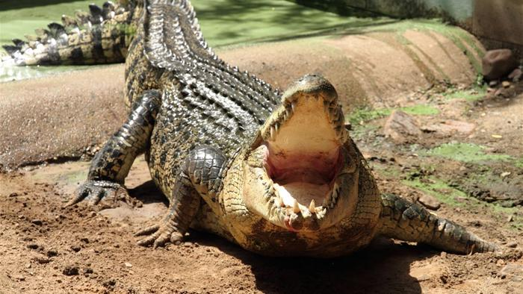

Write your answer.

Practice reading your answer.
Record your voice and listen!

