1. What is your favourite gemstone? Why?
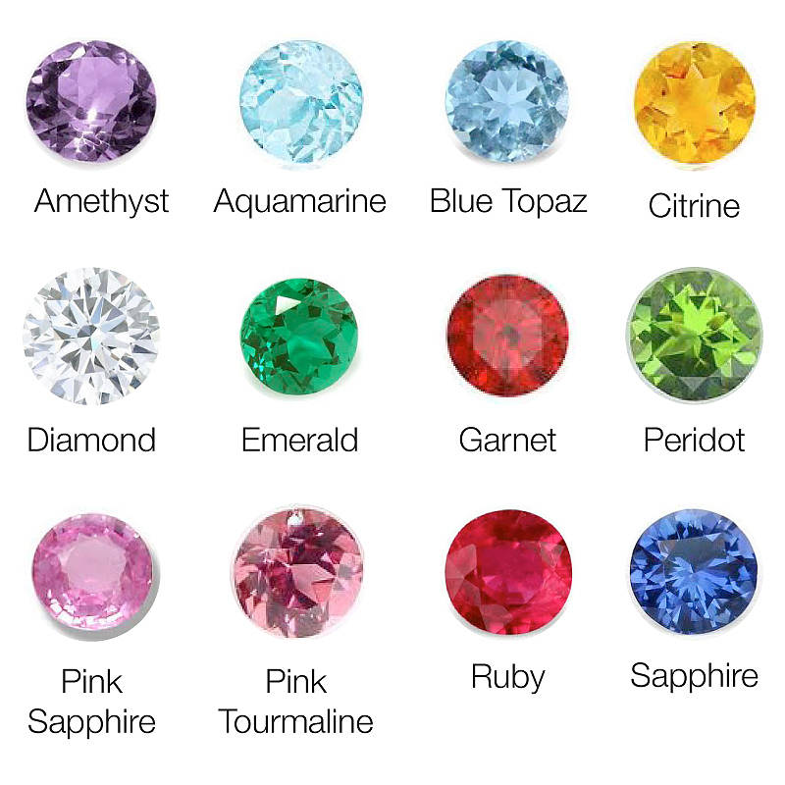
Write your answer.

Practice reading your answer.
Record your voice and listen!

