Monologue Activity

Imagine... | You are the person in this picture. What are you thinking?

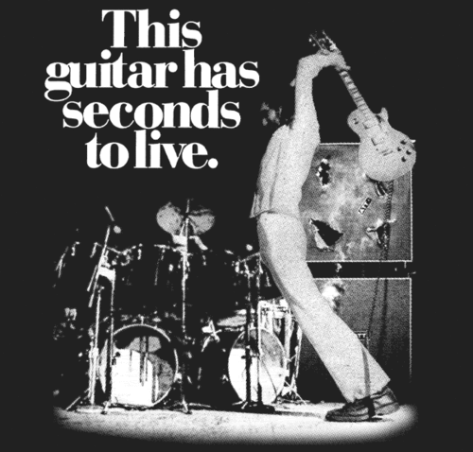

A monologue is one person speaking to explain how they are feeling and what they are thinking.

Write a script for your monologue, then practice reading it out loud. When you are ready, record your voice!

Monologue

