Partner A | You are preparing to barbeque some meat, and you ask your friend, Partner A, for help.
Partner B | You are an expert cook and you want to help your friend, Partner B, cook healthily.

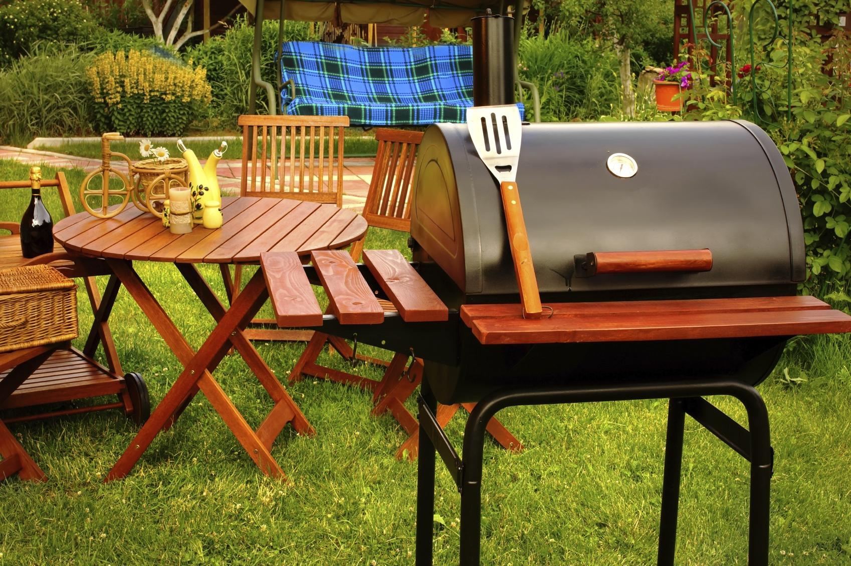

Write a script and record your speaking with your partner!

Partner A
Partner B
Partner A
Partner B

