- What is kelp?
  - Long, green, freshwater algae.
  - Long, brown, marine algae.
  - Large, brown, freshwater algae.
  - Large, green, marine algae.
  - None of the above.

Use the following image to answer questions 2, 3, and 4.
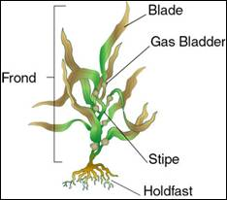

- Look at the picture. Explain how the holdfast helps the kelp survive in the ocean.

- Look at the picture. What part of the kelp is similar to a plant’s “stem?” What is this part used for?

- Look at the picture. Explain what would happen to the kelp if it loses all of its gas bladders.

- What problems would a young kelp face if the bottom of the ocean floor is covered in algae and invertebrates?
  - The kelp may be eating by other algae.
  - The kelp may not have space to photosynthesize.
  - The kelp may not be able to settle and grow.
  - The kelp might be dragged down to the bottom by the invertebrates.
  - Both a and b.

- Explain how marine fish use the middle area of the kelp forests.

- How is the canopy area of the kelp forests formed?
  - The stipes stick close together to form the canopy.
  - The tops of the kelp float to the surface to form a blanket.
  - The holdfasts of the kelp detach so the float to the surface.
  - Marine fish chew the blades of the kelp off so they float to the surface to form the canopy.
  - None of the above.

- Explain why the canopy is a suitable breeding ground for many marine fish.

- Why does the kelp need to float to the top of the sea?
  - So it can be warm.
  - So it can draw oxygen from the air.
  - So it can photosynthesize.
  - So it can provide a breeding ground for marine fish.
  - All of the above.

