Media Comprehension

- What does a star run out of to cause it to explode into a supernova?

- The star’s outer layer collapses and crashes into the centre with enough “momentum” to cause an explosion. Referring to the video only, what does “momentum” mean?

- List four elements that a supernova releases. Search the internet and provide two things that contain this element, and a picture of one of them.

Element Name | Things that contain this element | Picture
Carbon | - Diamond  - Humans | 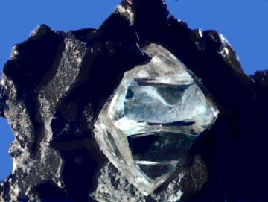
 |  | 
 |  | 
 |  | 
 |  | 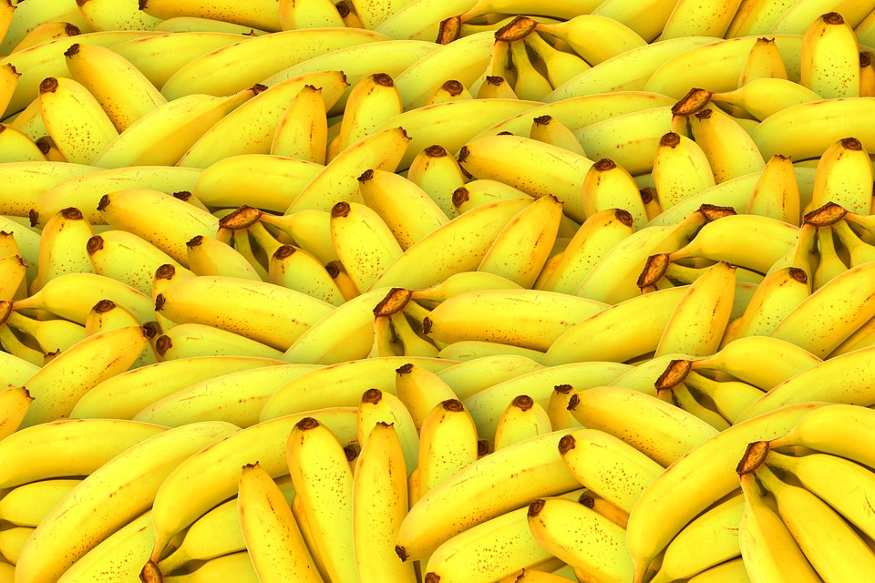
 |  | 
 |  | 
 |  | 
 |  | 

- What is the fate of these elements (where do they end up)? What are these elements important for?

- Explain how Earth has been affected by supernovas.

- Using information that you have learned in this video, explain why Earth is the only planet that we know that can support life.

