Media Comprehension

- This is the photograph called the “Pale Blue Dot.” 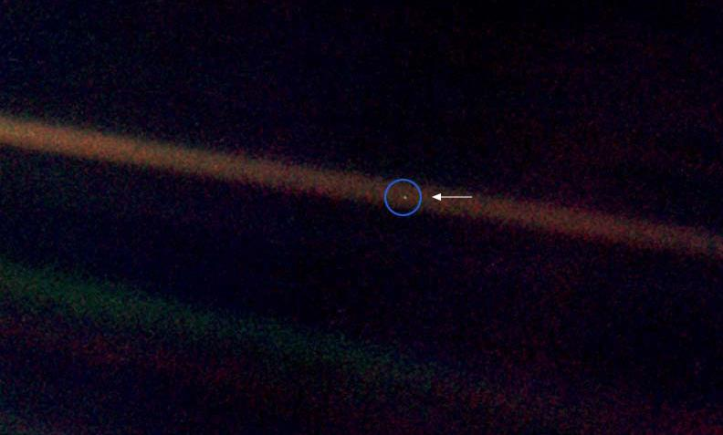
What is this arrow pointing at?

- What is “mote of dust” and “pale blue dot” referring to?

- What does it mean by “the Earth is a very small stage in a vast cosmic arena?” Explain how is this highlighted by this photograph of the Pale Blue Dot.

- Why should we learn to cherish our tiny world?

- List three ways that humans are destroying this planet.

- Here are four of the things that Carl Sagan listed that lived on this “mote of dust.” Provide a picture and two examples of each.

Thing that exists on the pale blue dot | Example | Picture
1) Confident religion | Christianity.  Buddhism. | 
2) Destroyer of civilizations
3) Inventor
4) Preacher of morals
5) Corrupt politician

