Partner A | You are Pluto. You think it stinks that you aren’t considered a planet anymore! You are defending yourself at a meeting of the planets.
Partner B | You are Saturn, a huge planet. You don’t think Pluto should be considered a planet. You are expressing your opinions at a meeting of the planets.

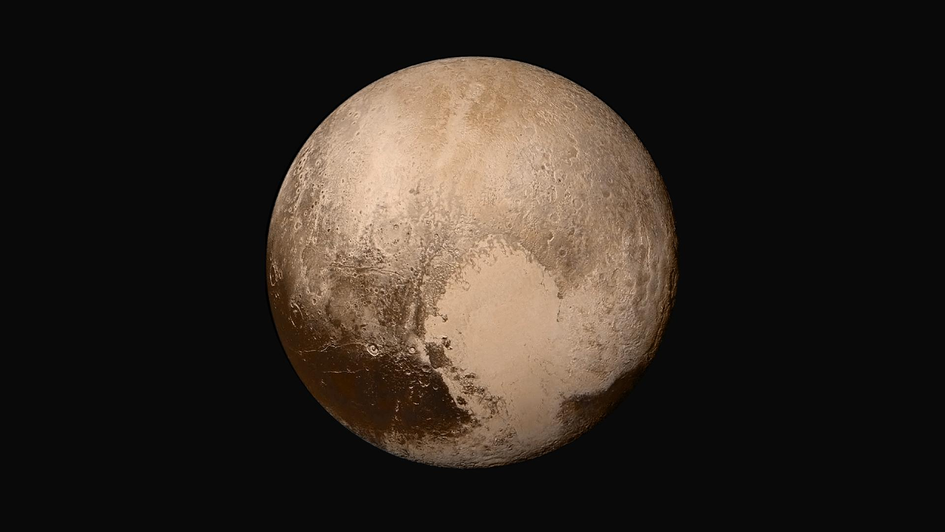

Write a script and record your speaking with your partner!

Partner A
Partner B
Partner A
Partner B

