Question | Do you think humans should and will one day live in space?

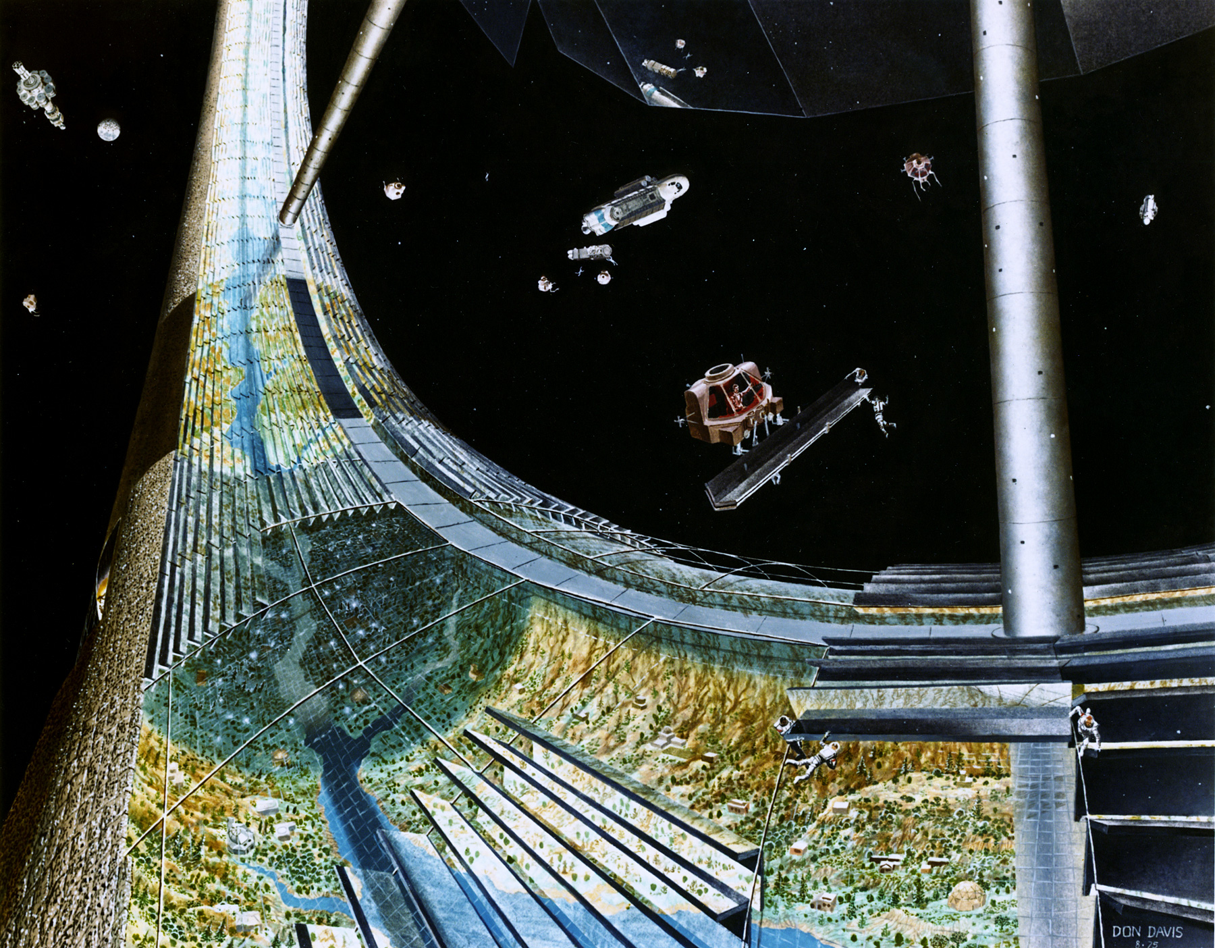

Write a script to tell your opinion and practice reading it out loud. Then, record your voice!

My Opinion

