Describe | Imagine you are describing this view in space to a person who cannot see this picture. How would you describe it? Describe how this picture looks, sounds, feels or smells like!

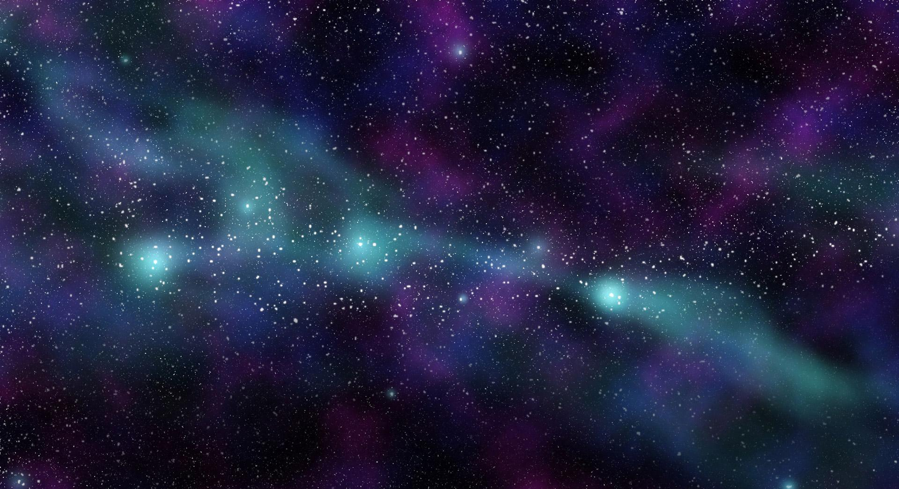

Write a script with your description and practice reading it out loud. Then, record your voice!

Description

